IT CONNECT WORKSHOP GUIDE – BREAKING AES LIKE A BOWSSS!
By : Martin Lemay, CSO @ Devolutions
CISM, CISA, CRISC, OSEE

Philippe Dugré, Application Security Specialist @ Devolutions
B.Ing., OSCP

I. SETUP 2
II. CHALLENGE 1 3
III. CHALLENGE 2 3
IV. CHALLENGE 3 4
V. CHALLENGE 4 4
VI. CHALLENGE 5 5
VII. SOLUTION 1 6
VIII. SOLUTION 2 6
IX. SOLUTION 3 7
X. SOLUTION 4 8
XI. SOLUTION 5 9

SETUP

For the workshop, the setup below was prepared. The Amazon AWS virtual machine is running a Django web server. That server exposes cryptographic APIs which encrypt or decrypt data sent by the client. Your workstation or laptop is the client. It should run Python 3 with your preferred IDE.

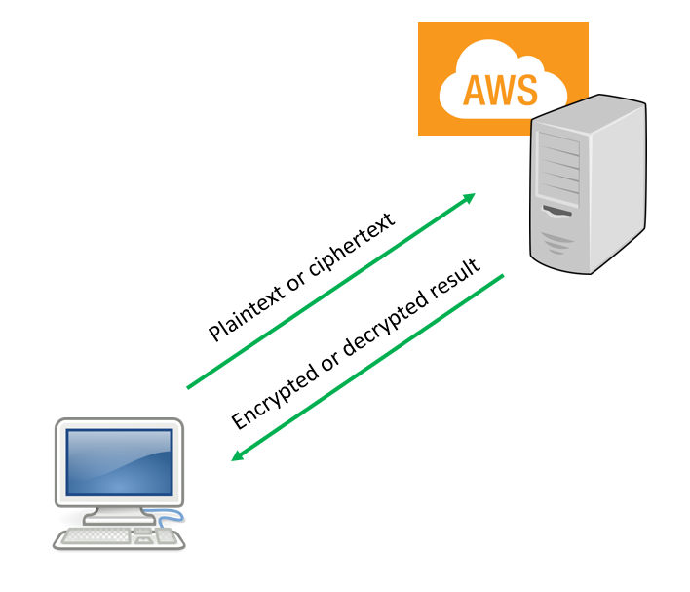
Image 1 – Setup Overview

CHALLENGE 1

Task : Encrypt multiple blocks of AES using the crypto1 API. The secret key is hidden on the web server.

Hint : Use the code below to encrypt a block of AES.

import requests

# Sending request to web server
payload = { 'plaintext' : 'secret message !' }
response = requests.post('http://35.173.236.202:8000/crypto1/', data=payload)

# Print response
print(response.text)

Note : You need Internet access.

CHALLENGE 2

Task : Attack the padding to produce a valid and unexpected output.

Hint : Use the code below to code your attack. Try to modify the last byte of the ciphertext to every possibility.

import requests

# Sending request to web server
payload = { 'plaintext' : 'secret message !' }
response = requests.post('http://35.173.236.202:8000/crypto2/', data=payload)

ciphertext = response.text

# Sending request to web server
payload = { 'ciphertext' : ciphertext }
response = requests.post('http://35.173.236.202:8000/crypto2/', data=payload)

# Print response
print(response.text)

CHALLENGE 3

Task : Bruteforce the controlled plaintext to recover hidden message. Decryption is not available.

Hint : Use the code below to code your attack.

import requests
from binascii import hexlify, unhexlify

# Sending request to web server
payload = { 'plaintext' : ' abcdef0123456789abcdef0123456789 ' }
response = requests.post('http://35.173.236.202:8000/crypto3/', data=payload)

# Print response
print(response.text)

CHALLENGE 4

Task : Implement a padding oracle attack against the last cipher block.

Hint : Use the code below to code your attack.

import requests

# Sending request to web server
payload = { 'plaintext' : 'abcdef0123456789' }
response = requests.post('http://35.173.236.202:8000/crypto4/', data=payload)

ciphertext = response.text

# Sending request to web server
payload = { 'ciphertext' : ciphertext }
response = requests.post('http://35.173.236.202:8000/crypto4/', data=payload)

print(response.text)

CHALLENGE 5

Task : Attack this algorithm following the proper methodology.
Hint : Use the code below to code your attack.

import requests

# Sending request to web server
payload = { 'plaintext' : 'abcdef0123456789' }
response = requests.post('http://35.173.236.202:8000/crypto5/', data=payload)

print(response.text)

SOLUTION 1

import requests

# Sending request to web server
payload = { 'plaintext' : 'secret message !secret message!' }
response = requests.post('http://35.173.236.202:8000/crypto1/', data=payload)

# Print response
print(response.text)

SOLUTION 2

import requests
from binascii import hexlify, unhexlify

# Sending request to web server
payload = { 'plaintext' : 'secret message !' }
response = requests.post('http://35.173.236.202:8000/crypto2/', data=payload)

ciphertext = response.text

for i in range(0, 256):
c = ciphertext[:-2]
c += format(i, 'x').zfill(2)

# Sending request to web server
payload = { 'ciphertext' : c }
response = requests.post('http://35.173.236.202:8000/crypto2/', data=payload)

# Print response
print(c, response.text)

SOLUTION 3

import requests
from binascii import hexlify, unhexlify

plaintext = 'abcdef0123456789'

# Bruteforcing block 1

found = []

for i in range(1, 16):
p = plaintext[ :-i ]

# Sending request to web server
payload = { 'plaintext' : p }
response = requests.post('http://35.173.236.202:8000/crypto3/', data=payload)

saved = response.text[:32]

for j in range(0, 256):
pp = p + ''.join(found) + chr(j)
payload = { 'plaintext' : pp }
response = requests.post('http://35.173.236.202:8000/crypto3/', data=payload)
if saved == response.text[:32]:
found.append(chr(j))
print("Found %c" % found[i-1])
break

SOLUTION 4

import requests
from binascii import unhexlify, hexlify

ciphertext = "b63bd404b61da93925d3465de12c9fe78fa14dbd3ed4601d10781876d936d845"
cipher = unhexlify(ciphertext)

# Sending request to web server
payload = { 'ciphertext' : ciphertext }
response = requests.post('http://35.173.236.202:8000/crypto4/', data=payload)

known = []
skip = 1

print(response.text)

for i in range(15, -1, -1):

for j in range(0, 256):
x = b""
x += hexlify((j ^ cipher[i] ^ (16 - i)).to_bytes(1, "little"))
for m in range(0, 15 - i):
x += hexlify((known[len(known)-m-1] ^ cipher[i + m + 1] ^ (16 - i)).to_bytes(1, "little"))

# Build blocks
c = ciphertext[:i * 2] + str(x)[2: (16 - i) * 2 + 2] + ciphertext[i * 2 + (16 - i) * 2:]
#print(i, x, j, c, known)

payload = { 'ciphertext' : c }
response = requests.post('http://35.173.236.202:8000/crypto4/', data=payload)

if response.status_code == 200:
if ciphertext == c and skip == 1:
skip = 0
else:
known.append(j)
print(chr(j), j, c)
break

SOLUTION 5

import requests
from binascii import hexlify, unhexlify

# Send a first small request to get the encrypted secret

payload = {'plaintext': 'a'}
response = requests.post('http://35.173.236.202:8000/crypto5/', data=payload)
print(response.text)

c1 = unhexlify(response.text)

# Send a larger request to generate a known keystream
payload = {'plaintext': 'a'*30}
p2 = payload.get('plaintext').encode()

response = requests.post('http://35.173.236.202:8000/crypto5/', data=payload)
c2 = unhexlify(response.text)

# p1 ^ c1 = keystream
# p2 ^ c2 = keystream
# p1 ^ c1 = p2 ^ c2
# p1 = c1 ^ p2 ^ c2
secret = bytes([a ^ b ^ c for a,b,c in zip(c1, c2, p2)]).decode()[1:]

print(secret)

